Silesian University of Technology

Hierarchical Control Lab-6

Title of the exercise:

“ Identification of complex systems”

Date of the exercise:
13.12.2013

Group Students:
Ismail Kalay
Aiganym Kadrina

Introduction:
During the laboratory, students use the sensitivity analysis for gradient estimation of non-linear
dynamic systems parameters. As examples of such systems, the Hammerstein and Wiener models
are used.
Constants for section 5 : a=2, b=3, k=1 ,T=2

Task 1: Construct the extended model for the identification experiment scheme in the Fig. 2 and the
following performance index:
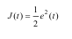

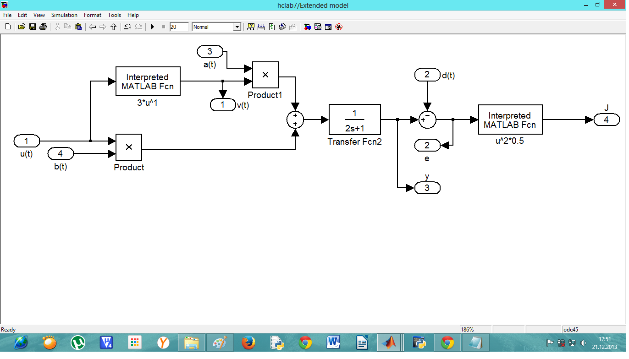

Task 2: Construct the sensitivity models for all the estimated parameters

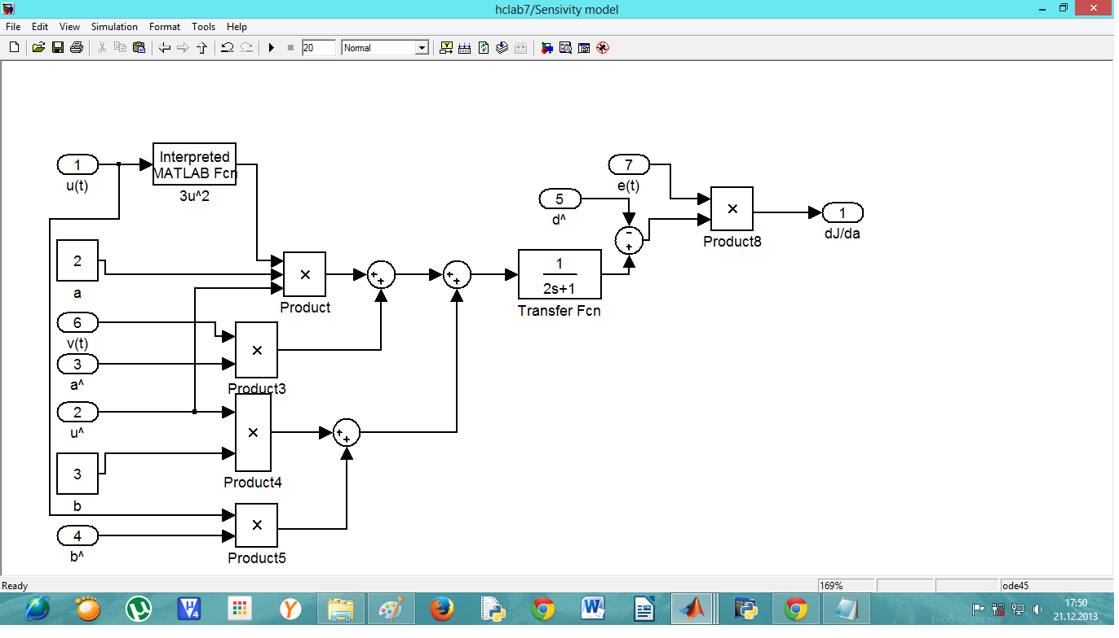
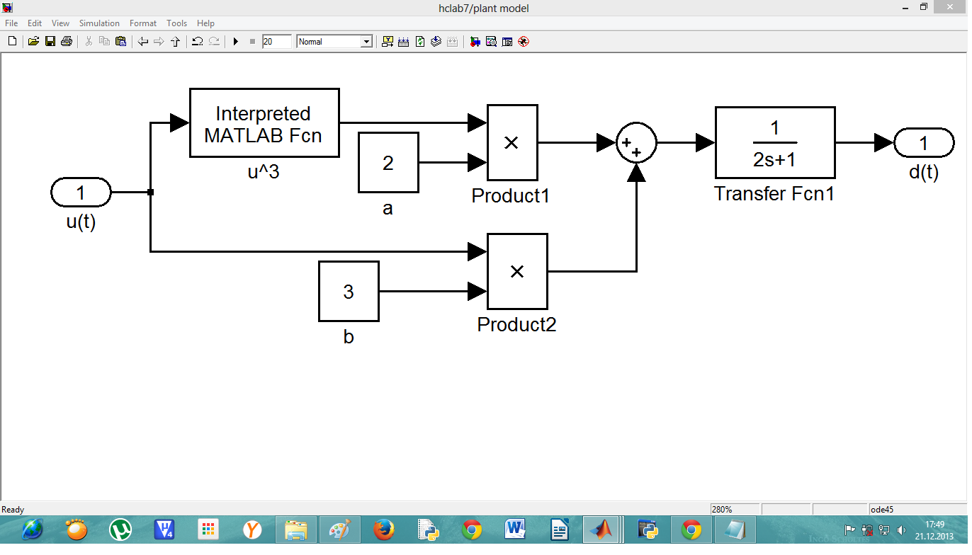
Task 3: Construct the plant model

Task 4: The Whole System
Implement the simple gradient descent minimizing algorithm that uses the gradients
obtained in the point 3 to estimation (on-line adaptation) of the model's parameters
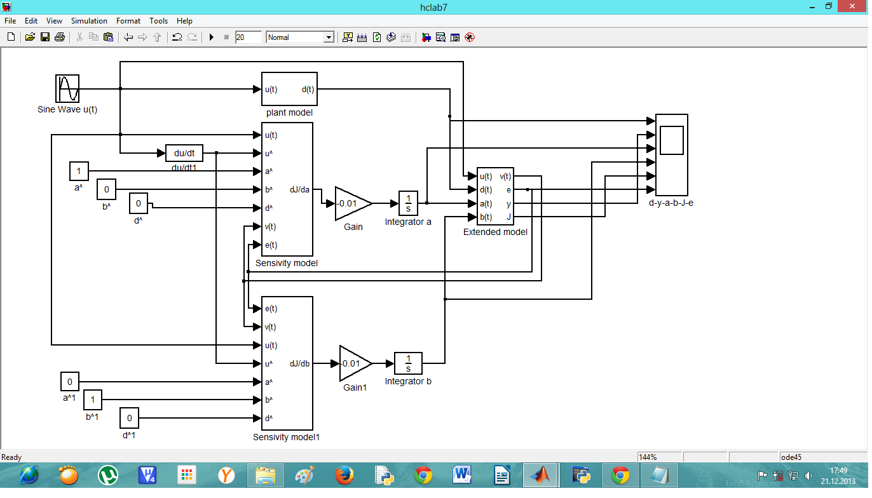

Results:

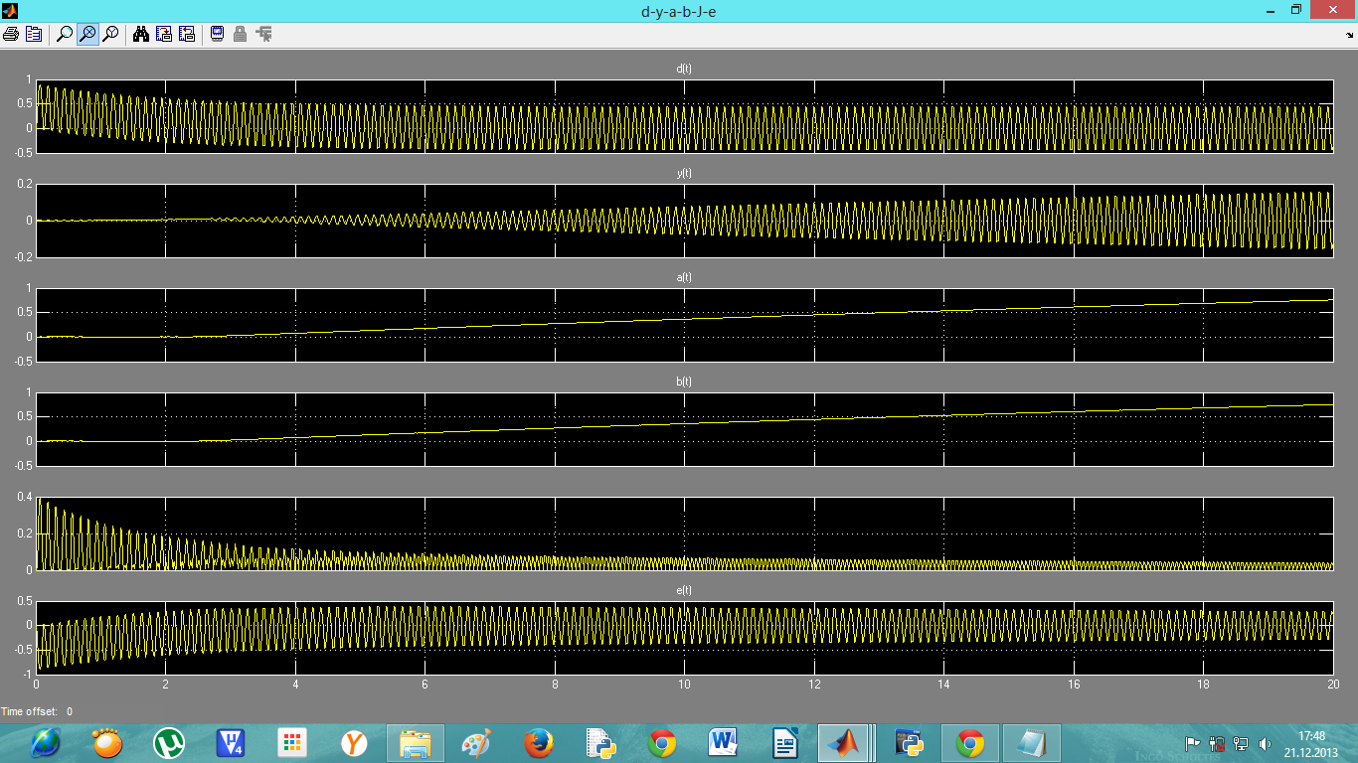

Conclusion:
our section number is 5.we used these parameters in our group.a=2, b=3, k=1 ,T=2

As an input: u(t)= 3sin(2*pi*50)

In this lab we learned how to use the sensitivity analysis for gradient estimation of non-linear
dynamic systems parameters.

